LaToya Bicko
376 Fairfield Avenue
Johnstown, PA. 15906
Cell: (814) 691-0902
Moorela25@hotmail.com

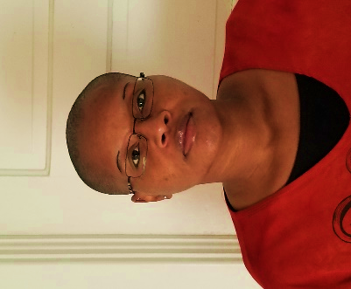

Cover Letter:

I welcome the opportunity to be your next contributing writer.
Currently, I am a freelance writer for the Tribune Democrat and The Maverick Observer in Colorado, Springs. I am a remote writer for both positions. My interest in this position is a good work experience and a company with a good reputation in the community.

Education:
University of Alabama at Birmingham, Birmingham, Alabama
Bachelor of Arts: Communications

Work Experience:

The Maverick Observer-February 2022 to current
- Remote Freelance Feature Writer
Profiling people in Colorado Springs area.

Coloradan Features:

The Psychology of Nude Art Modeling: From a Naked Guy Named Dave
Death: Five Wishes, Funeral Dishes, and Earthly Bliss
Dharma Kids: Sweet Routes to Mindfulness
Fluent in Portuguese, English, and Black Skin Photography
The Private Side of Missing Persons

Tribune Democrat Newspaper-August 2020 to current
Freelance Writer (as needed)

